IMP Planner – Strand 3 Build Process: Phase 2

Object
The object of this document is to detail the process of completing the following tabs on the customer ‘Strand 3 Standard Workbook API’, in relation to the Strand 3 second phase of the build process:
- Manipulating Budgets
- Month Profiling
- Scenarios
- Income
- Expenditure
- Brought Forward Balances
- Funding Check
- ScenarioSummary
- Checklist & Completion

Process

Manipulating Budgets

Function
Before any information onto the workbook, the source data provided will need to be reviewed. Some data may be suitable to be pasted straight into the workbook, however most likely we will need to manipulate the customer data before entering it. We would do so for the below reasons:
- Efficiency – where customer has provided data over multiple tabs/ spreadsheets, we can combine these into one document for ease of reference
- Clarity – where customer has provided a lot of information within their data, we can edit and remove columns/ lines/ text that is not required
- Formatting – where the customer data is not laid out in way that will be easily transferrable to the workbook
NOTE: Copies will need to be saved before in the Manipulated folder to ensure data integrity before being edited. Do not edit the original data files provided.

Power Query: Combining Budgets
The most common form of manipulation is combining multiple budgets via Power Query.
The basic process behind this is the following:
- Open a new Excel document, select ‘Data’ and then ‘Get Data’
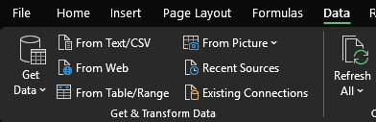
- Select the relevant option – likely to be file or folder.
- Load and transform the data in Power Query
- Adjust the data as required – removing columns or rows that are empty and removing additional data that we do not need
- Re-organise columns for ease of copying & pasting into the workbook
- Close and load the data.
Power Query can be complex and used in a variety of ways depending on the needs of the build, however the above will cover the basic steps.

General Adjustments
All budget rows that show as ‘0’ value are not required and can be removed.
Any locations that are not required for the budgets or build can be removed. Please consult the scope document before removing these locations.
Income lines will need to be set as negative and expenditure lines will need to be set as positive, to ensure consistency within IMP when imported.
Ensure any calculated values/ formulas are set as static values before importing.
Unnecessary columns can be removed, for example:
- Unless requested, we do not need future year values
- We do not need the Ledger code, as we have a formula to confirm this in the workbook

Month Profiling

Function
Month profiles help with customer forecasting and they show when funds are due to spent or received. We have 23 standard profiles within the workbook, however sometimes customers require bespoke profiles.

Bespoke Profiles
The scope document will confirm whether additional/ bespoke profiles are required. These are usually contained within the budget data.
NOTE: Sometimes, the customer will provide an excessive number of profiles. This is where the customer is repeatedly using specific profiles for specific lines, resulting in multiple unique month profiles that are only applied to individual lines. For example, if the budget contains 100 lines and there is a unique month profile requested for over 70/80 of these lines, this would be an excessive number of profiles. Please query with the Lead Consultant. This is likely to be showing cash flow, not month profiling, and these are unlikely to be useful for the customer.

Scenarios

Function
Scenarios are used to contain budget information. The scope will detail which scenarios are required and confirm which documents will be used to build the scenario.
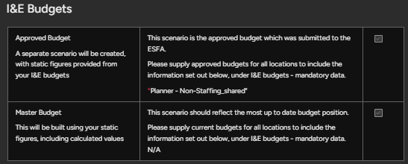
We would use the source documents provided here as a basis for our scenarios on the ‘ScenarioAPBUD’ tab.
All scenarios on the ‘ScenarioAPBUD’ tab should be as faithful to the customer source documents as possible, except for instances of the below:
- Where coding needs to be adjusted due to errors (these should be noted in the queries document or build notes)
- Where the scope has requested specific adjustments to be made

Approved Budgets
Approved budgets are finalised budgets within the trust, where the trust has confirmed that these are the correct values to be spent or received for the year.
Where there is an Approved budget required, use the scenario code ‘APBUD[year]’, i.e. APBUD2425 in the ScenarioCode column for these lines.

Master Budgets
Master budgets contain the most up-to-date information that the trust is using to build their budget.
Where there is a Master budget required, use the scenario code ‘MASTER_OG’ in the ScenarioCode column for these lines.

Bespoke Budgets
If any additional/ bespoke budgets are required, these should be noted under ‘I&E Budgets’ section. These should be relatively straightforward to action, following a similar process to adding an Approved Budget. A Scenario Code is usually provided by the Lead Consultant in the scope.

Master Scenario
Approved, Master or bespoke budgets are static scenarios. This means that the values do not change and they are used for information/ comparison purposes. However, their calculated lines and ongoing scenario will be separate to these budgets. This is known as the Master scenario.
Where both a Master Budget and an Approved budget have been provided, we would use the MASTER_OG data in the ‘Master’ scenario. If only an Approved budget is provided, we would use this for the ‘Master’ scenario.
The baseline data is imported into the ‘Master’ scenario. This is not to be confused with the static MASTER_OG scenario. This is a separate scenario, which is the default scenario in IMP and will include the data from the most up-to-date scenario the customer has provided, as well as calculated lines.

Scenario Summary Table
Scenario Type | Scenario Code | Function
Master | None, as this is the default scenario | Default scenario containing calculated lines and up-to-date data
Master Budget | MASTER_OG | Frozen scenario containing the most up-to-date data provided by customer
Approved Budget | APBUD[year] | Frozen scenario containing the Approved budget data
Bespoke Budget | This can vary and will be confirmed in the scope document | The function will depend on the individual requested budget. Usually these are included for comparison purposes.

Errors: General
Any errors will show in the ‘Will import if 0’ column. You can expand to view what the exact error is and amend the lines accordingly.
Common errors include:
- MATEditOnly requiring an amendment from TRUE to FALSE
- Values entered in ‘YearValue’ column where the line is set as ‘TRUE’ in the ‘Calculated’ column
- Duplicate budget lines – we may need to add ‘LINE 1/ LINE 2’ etc after budget lines where customer has identical lines

Errors: Coding
Finance code errors can have multiple causes, including:
- Finance code is not available to location – check the ‘FinanceCodesBudget’ tab to view the code and see which locations are available for the code
- Finance code is on a different ledger to department code – check the ‘FinanceCodesBudget’ tab to view the code and check the ‘Dept’ tab to view the department. Both will show which ledger the codes are attached to
- Finance code does not exist in Planner – check the ‘FinanceCodesBudget’ tab to see if is included in there
The above issues will likely need to raised as queries for the customer/ Lead Consultant and we may need to make coding assumptions.

Income and Expenditure

Function
These tabs are separated for ease of data entry, however they will both form the Master (default) scenario in IMP. Both tabs will auto-populate with default calculated lines based on the school type.

Scope
You can find out what calculations are required for the build in the ‘Calculations’ section of the scope document.

Process
Copy and paste the income lines into the ‘Income’ tab, ensuring the signage is correct in the YearValue column (these should be negative, except for recharges etc.). This will be the same process for Expenditure, ensuring the signage is also correct (this should be positive).
Regarding the default lines on both tabs, all unnecessary lines can be removed – for example, if the customer does not require SCA funding, the default lines for this grant can be removed. This should then leave you with only relevant default lines and the customer budget lines.
The aim now is to ensure that all lines that require calculation have the following:
- A calculator allocated in the ‘Calculator’ column
- The correct option in the ‘Calculated’ column (set to ‘TRUE’)
- No values in the ‘YearValues’ column (as these will be calculated in IMP)
- No duplicated lines (i.e. default lines for PE Grant as well as PE Grant values left on this tab from the customer budget)
NOTE: Grants (TPAG/ TPECG/ CSBG etc.) have a slightly different process to the above. We would keep customer values where they are provided. Otherwise, where we need to provide values for the customer, these are located in the grant database/ calculation documents. Please see document: Strand 3 – Workbook – Grants for more information on this process.
There is no set order or process for these tabs, however the below process may provide a helpful basis:
- Start with the first default line, i.e. Central Charge income.
- Locate central charge income in the customer budget lines and note the finance code.
- Enter this finance code into the ‘FinanceCode’ column on the default Central Charge line.
- Filter by this finance code. This will show both the default lines and the original customer budget lines.
- Allocate the relevant department codes, fund codes and notes used in the customer budget lines to the default lines.
- Remove customer budget lines and un-filter. You should now have lines set up to be calculated, using the required coding.

Errors
Any errors will show in the ‘Will import if 0’ column. You can expand to view what the exact error is, and amend the lines accordingly.
Common errors include:
- MATEditOnly requiring an amendment from TRUE to FALSE
- Values entered in ‘YearValue’ column where the line is set as ‘TRUE’ in the ‘Calculated’ column
- Duplicate budget lines – we may need to add ‘LINE 1/ LINE 2’ etc after budget lines where customer has identical lines

Brought Forward Balances

Function
These are unspent values from the previous academic year carried forward.

Scope
In the scope document, it should be confirmed whether brought forward balances are required and where they can be located.

Process
Add required values to the template lines in the BFWD tab, removing lines that are not required (i.e. removing Capital lines where customer does not have brought forward Capital values).
NOTE: If you are unsure of which lines need to be populated, please check the Lead Consultant. Brought forward balances are not always clearly labelled or indicated in customer documentation, so differentiating between Capital/ Reserved/ Unreserved may require a further discussion.
Brought forward balances will need to be entered for all scenarios.
If the customer does not require brought forward values, set all lines to 0.

Funding Check

Function
This check is set up to ensure that any variances between the funding statement from the DFE and the customer’s budget GAG values are flagged early in the build, and noted in the build notes.

Scope
There may be notes regarding expected variances in the scope. These would be found under ‘I&E Budgets’ if applicable.

Process
Identify the codes in the base customer budget which are being used for GAG funding. The base customer budget here refers to the budget that will be used to form the Master scenario. This will be the MASTER_OG, unless only an Approved Budget has been provided.
Enter the finance and department codes into the yellow table. Adjust the scenario code at the top of the table to ‘MASTER_OG’ if required.
Where variances appear, follow the below checks to identify the cause of the issue:
- Look through the funding statement and see if the variance matches any values on there. If so, add a note confirming that the relevant funding element has not been included
- Check the budget lines to see if GAG lines have been spread over multiple budget lines. This is usually split over Deprivation/ Minimum Funding Guarantee/ Lump Sum etc. Update the yellow table accordingly to include all relevant codes
- Check the budget lines to see if additional lines have been included (i.e. non-GAG values on a finance code that has been used for GAG lines) and add a note
Where a cause cannot be identified, update the ‘Notes’ column, including any details that will be useful for the Lead Consultant.

Scenario Summary

Function
This tab includes a variety of checks to ensure that the build has met the required criteria and does not include any errors.

Import Errors
These should all show as ‘0’ at the end of the build. If not, review the relevant tab and fix the error.

Rows & Year Values
This is a sense check and not a definitive set of rules, with the intention being to review all data entered and ensure it looks sensible. Review the differences between the rows and year values, following the guide provided in the cascading ‘Notes’ section below.
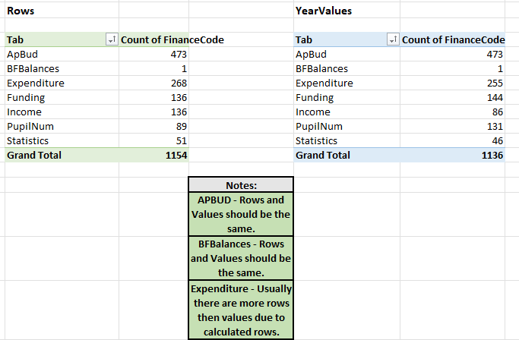
Where the values do not follow the expected pattern outlined in the ‘Notes’ section, review and see if there are any issues with the data entered on the relevant tab. If not, this is no cause for concern.

Budget Values
Enter the totals from the customer budget documents provided in the ‘Budget Total’ column. Where are variances, check the data or provided notes for the Lead Consultant.

General Sense Checks
At the bottom of the page, there are three pivot tables which will show the number of locations using calculated lines, different year groups and school types. Review the information to ensure that this matches the scope requirements and location totals. Where these show as blank, make amendments in the relevant tabs to rectify.
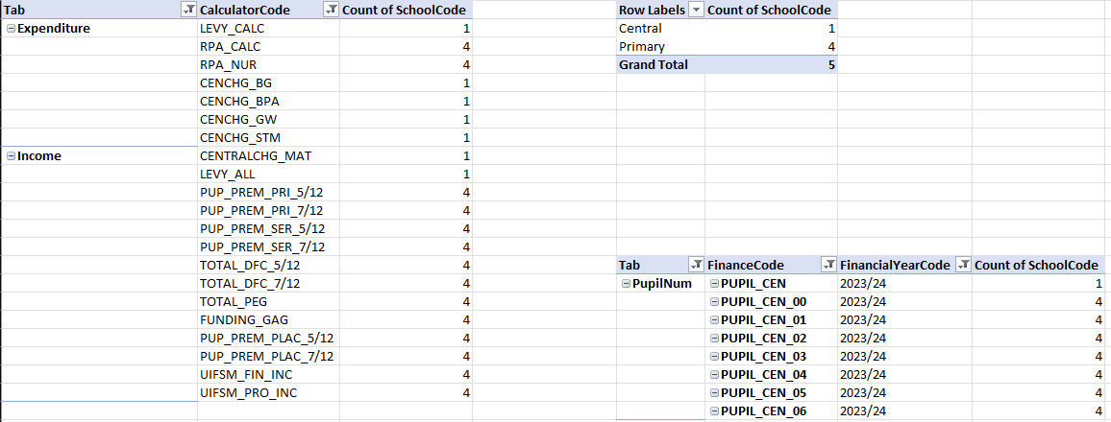

Checklist & Completion

Function
This is a final check on workbook errors and to ensure that the data in the workbook is correct, relevant and complete.

Error Checks
Review any lines where the ‘Check’ column is not showing as ‘0’. Common errors include additional locations being included within the trust, where budget lines have not been requested.
Add a note to any errors that are showing, which are not an issue and can be ignored by the Lead Consultant.

Checklist
Go through each question in the checklist, updating the ‘Check’ column with Yes/ No or N/A. Instructions are included in column B for each line.

Completion
Once the above has been done, you can sign your name in cell B44 to confirm the builder’s name and the date. The workbook is now complete.

